**AUTOMATION SYSTEM FOR VEHICLE DAMAGE DETECTION AND COST ESTIMATE BY USING COMPUTER VISION.**

09th November 2022

CONTENTS

1. INTRODUCTION 1

1.1 Chapter Overview 1

1.2 Problem Domain / Background 1

1.3 Problem Definition 1

1.3.1 Problem Statement 2

1.4 Research Motivation 2

1.5 Existing Work 2

1.6 Research gap 6

1.7 Contribution to the Body of Knowledge 6

1.7.1 Contribution to the problem domain 6

1.7.2 Contribution to the research domain 6

1.8 Research Challenge 6

1.9 Research Questions 7

1.10 Research Aim 7

1.11 Research Objectives 7

1.12 Scope of the Project 8

1.12.1 In-scope 8

1.12.2 Out-Scope 9

1.12.3 A Diagram Depicting the prototype feature 9

2 Methodology 10

2.1 Research Methodology 10

2.2 Development Methodology 11

2.2.1 What is the development methodology? 11

2.2.2. Requirement elicitation methodology 11

2.3 Design methodology 12

2.3.1 OOAD 12

2.3.2 SSADM 12

2.4 Development methodology 12

2.4.1 Testing methodology 12

2.5 Solution methodology 13

2.6 Project management methodology 13

2.6.1 What is the project management methodology? 13

2.6.2 Schedule 13

2.6.3 Resource requirements 16

2.6.4 Risk and mitigation 18

References 19

List of Figures

Figure 1 - A Diagram Depicting the prototype feature 9

Figure 2 - Gantt chart 15

List of Tables

Table 1 - Existing Work 6

Table 2 - Research Objectives 8

Table 3 - Research Methodology 10

Table 4 - Deliverables and dates 15

Table 5 - Software resources 16

Table 6 - Hardware resources 17

Table 7 - Data requirements 18

Table 8 - Risk and mitigation 18

# 1. INTRODUCTION

## 1.1 Chapter Overview

This introduction chapter provides a descriptive outline for the entire research project. Furthermore, the report will describe the magnitude and significance of the problem identified. The importance of conducting research is demonstrated by discussing research contributions and objectives. Additionally, this chapter offers comparisons with existing works.

## 1.2 Problem Domain / Background

Due to excessive use of private vehicles, lack of mental concentration, and busyness of people, road accidents have increased to some extent. The insurance claim process after an accident consumes considerable time and resources. This waste can be minimized by using proper technology. It will be more effective if the task of the agent who attends an accident and observes it and records the information can be done by an automated system. The damage can be identified by sending the vehicle photos taken by the vehicle owner to the system along with the insurance company.

Due to the mixed nature of scratches, it can be difficult to identify the damage from images. The project addresses a critical damage estimation method. Vehicle damage detection by using Vehicle damage classification, Image processing and Mask R-CNN model architecture. Adding multiple photographs at once as getting input and output (result) via messaging app instead of using a Web application.

## 1.3 Problem Definition

The difference between the ideal and actual settlement of a claim is known as claim leakage. Visual inspection and approval are being utilized to decrease claims leakage.

But doing inspection might take a long time and result in delays of claims processing. An automated system for doing review and approval will be of efficient assistance in speeding up the process. Uploading photos to a web app or mobile app to see the results in case of an accident is not practical. An automated system where you can contact a phone number previously provided by the insurance company and send images and receive results is more appropriate.

### 1.3.1 Problem Statement

Provide an automated system as the product by improving the damage detection accuracy of photos taken in poor lighting, a variety of vehicle models, and uncontrolled environments such as rain

## 1.4 Research Motivation

There are many systems available for vehicle damage detection. But in practice they are not very effective. The focus was on creating a more efficient system to minimize the problems that arise in practice.

## 1.5 Existing Work

|  |  |  |  |  |
| --- | --- | --- | --- | --- |
| **Citation** | **Brief Description**  **(Summary)** | **Improvement** | **Limitations** | **Critical Review** |
| (Shirode et al., 2022) | Authors has used 4 algorithms which are VGG16, VGG19, Resnet50 and Inception V3 for the implantation of damage detection and assessment.  To cover the exact damaged area , they have used Mask RCNN. | The damage, its severity, and the exact damage location can all be determined using the implemented models, By Fine-tuning VGG models they were able to increase the accuracy and provide accurate rate predictions for edge cases. By taking into account different backgrounds, light intensity and many other various factors, the Mask RCNN model accurately masks the damaged areas from the photos. | The model can be effectively trained by expand the data to get better results. Using the proper resources and information, it is also possible to estimate the cost of repairs. | They trained the model using a very small data set. |
| (van Ruitenbeek and Bhulai, 2022) | The frequent switching of drivers necessitates a quick and precise inspection system that can identify minor problems and classify them according to their type. A damage detection model is created to handle this.  to find car damage and divide it into twelve groups. To improve the performance of detection, a variety of deep learning algorithms are applied, and the impact of various transfer learning and training procedures is assessed. The final model can precisely identify minor defects in a variety of environments, including water and dirt, after being trained on more than 10,000 damage photographs. An review of the model's performance by experts indicates that it performs comparably. | They have created the cross-performance between the training the model in dataset and evaluating the model on dataset using the (x, y) axis to improve the robustness. It has been never used while having two different data sets. | They have used the small data set to trained the model in some factors like different light conditions, camera angles, and zoom level. Because of this they had get the sparse confusion matrix. It makes the comparison very hard. | In the paper they have created their own dataset and used that as their first approach. So that they can managed to create their own parameters for the model training. It made some point easy while some point hard. For an instance, they cannot find the vehicles images for different light conditions, different camera angles, and photos’ zoom level also optimal. Given that factors they couldn’t get the fair confusion matrix. However, they managed to improve the previous research by categorizing the image damage classification and localization. Furthermore, they have used domain exports to assess the performance in production. |
| (Zhang et al., 2020) | This describes a deep learning-based detection algorithm used to detect vehicle damage to deal with the compensation problem of traffic accidents. | The author was able to better adapt to different aspects of car damage images by using the proposed transfer learning and improve Mask R CNN-based vehicle damage detection method. | They have used the small data set to trained the model. | A better result can be obtained by increasing the size of the data set and expanding the type of damage. |
| (Kyu and Woraratpanya, 2020) | Various deep learning-based algorithms for vehicle damage detection techniques are described in this article. They experimented with the deep learning-based pre-trained VGG models by random initialization. Those models are followed by supervised fine-tuning and transfer learning with L2 regularization technique to fit the specific tasks. | They examined those models and discovered that regularization and transfer learning can produce outcomes that are more effective than those obtained through fine-tuning, and also find the performance of VGG19 is better than VGG16. | The issue of overfitting in models still exists for the proposed approach. | They mentioned the need for a high-quality data set, including a car's features (make, model and year of manufacture), location information, type of damaged part and repair cost. It makes easier to predict the cost of the damaged part with more reliability and accuracy. |
| (Waqas et al., 2020) | The methodology used is SIFT (Scale Invariant Feature Extraction). SIFT is a feature extraction technique that is capable of extracting distinctive features from a scale-invariant image, and such factors are the main reason for choosing this method is the variation for scale and the angle at which the image is taken.  The technique's goal is to identify invariant features in an image and compare them to equivalent regions of an additional image that was captured from a different perspective. |  | To improve the accuracy of the cost and to be more peculiar to a single vehicle, the make, model, color and the year of manufacture can be taken.  The automatic detection of the aforementioned information, as well as the addition of the vehicle's make, model, color, and the year of manufacture, can be added as a development of the application's internal operations. |  |
| (Harshani and Vidanage, 2017) | Vehicle damage is divided into three groups using MobileNet: moderate damage, large damage, and no damage. | The algorithm parameters were adjusted like dropout rate, optimizer and custom layers with activation functions were introduced. |  |  |

Table 1 - Existing Work

## 1.6 Research gap

There are recent studies that pinpoint a vehicle's damages. But there is no research or products to identify damage in a vehicle by using photographs which are taken in an uncontrolled environment such as rain. (Waqas et al., 2020)

. There is a need for research on how to accurately detect damages, offer a damage estimation, and use Deep Transfer Learning Models to increase the accuracy of damage level identification.

## 1.7 Contribution to the Body of Knowledge

### 1.7.1 Contribution to the problem domain

Scanners detect damage to the vehicle's body. Through this project, the damage caused to the vehicle body is identified through the images obtained from the mobile scanner.

### 1.7.2 Contribution to the research domain

Increasing the accuracy of critical vehicle damage detection by using multiple images.

## 1.8 Research Challenge

* Identify the most accurate machine learning models for damage detection.
* Identify various use cases of image preprocessing techniques.
* Reducing model training time.
* Creating a dataset of vehicle side view images.
* Image labeling.

## 1.9 Research Questions

Research Question 1:

How to improve damage detection accuracy by using multiple images?

Research Question 2:

How to improve damage detection accuracy of photos taken in poor lighting?

Research Question 3:

How to detect scratches in photos taken in an uncontrolled environment such as rain??

## 1.10 Research Aim

The research is being conducted to design, develop and evaluate a system for vehicle damage detection by training a model to detect the damage and estimate the cost in a high accuracy rate.

## 1.11 Research Objectives

|  |  |  |
| --- | --- | --- |
| **Objective** | **Description** | **Learning Outcome** |
| Literature Review | In-depth research on the following areas   * Recognizing the need for such a system in the auto insurance industry. **– RO1** * To identify proper dataset creation methodology. **– RO2** * To identify suitable machine learning algorithms to achieve good accuracy. **– RO3** | L01, L06 |
| Requirement Elicitation | In-depth gathering of users' needs.   * To identify real user needs for the community. * Analyze the collected requirements. * Identify system functionality. | L02, L03, L04, L05, L06 |
| Design | Development of the system.   * Create a simple web application and automated system with the image recognition model and the implementation process. * Design the back-end and front-end (User interface) architecture of the web application and the automated system which will use through a messaging app. * Create user-friendly application interfaces. | L03, L04, L06, |
| Implementation | Creating a functional prototype of a car damage-detecting detecting system using the appropriate hardware and software components.   * To identify the exact damage area and the level of damage severity of a the damaged vehicle. * To evaluate severity levels and identify the most accurate severity of damage. * Increasing the accuracy of critical vehicle damage detection from images and labels define damage classification. * Implementation of a system that can assess the severity of damage to a vehicle from an image and estimate the cost of severe damage. * Generate car damage report including damage type and severity and estimated cost.   . | L03, L04, L06 |
| Evaluation | * Create a test plan for each unit and model to validate system requirements. **– RO1** | L04, L06 |

Table 2 - Research Objectives

## 1.12 Scope of the Project

### 1.12.1 In-scope

* Assessment of dents, scratches, windshield damage and paint damage on the vehicle's outer metal body.
* Identify the damaged area with accurate measurements.
* The classification of detected damage identifies whether it is a dent or scratch or both.
* Find the intensity of the damage.
* Giving the closest estimate based on previously obtained details.

### 1.12.2 Out-Scope

Damage to the vehicle due to a vehicle collision or other external impact is divided into two parts, internal and external (Outer body damage ). This project only addressed damage to the exterior of the vehicle but does not consider weather damage and rear-end damage such as broken taillights and a cracked bumper which are into outer body damages.

### 1.12.3 A Diagram Depicting the prototype feature

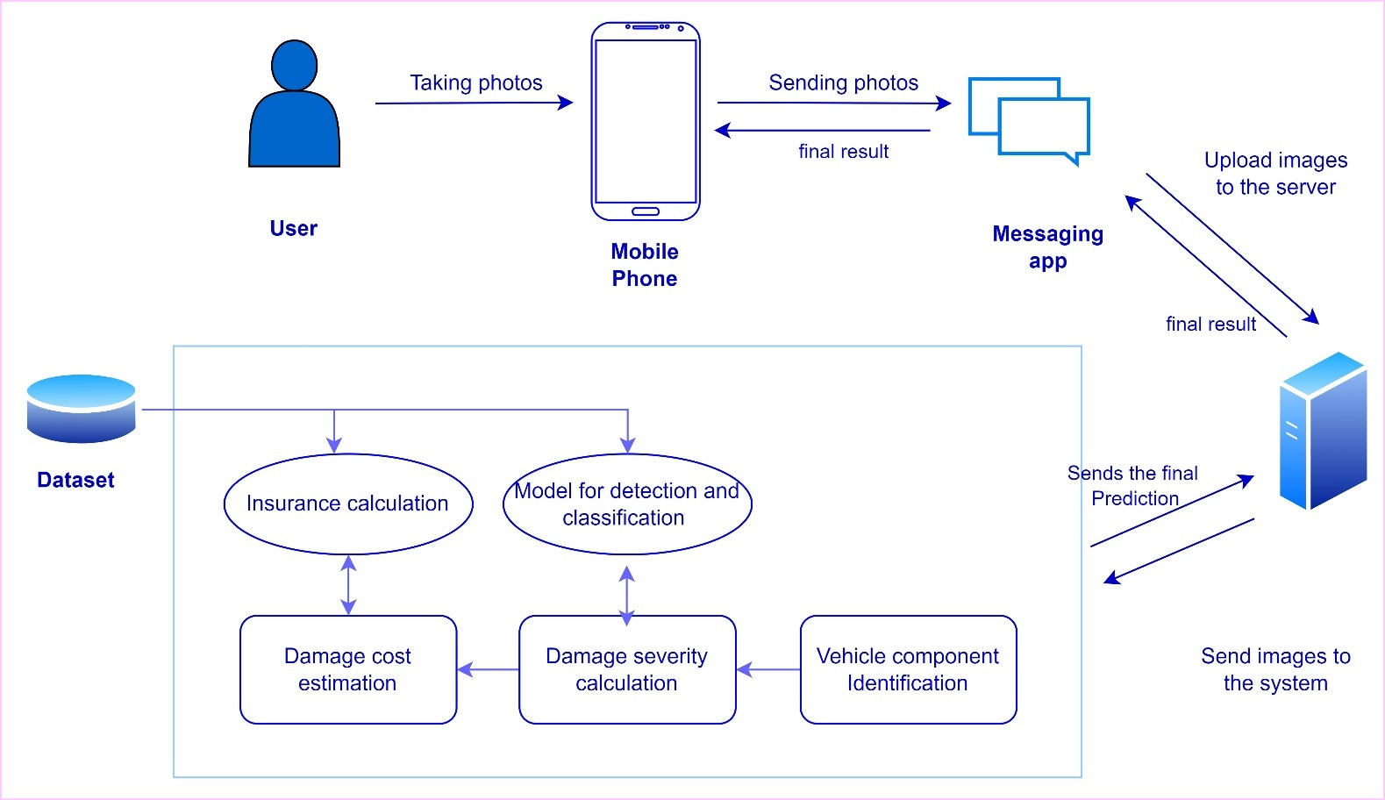

Figure 1 - A Diagram Depicting the prototype feature

# 2 Methodology

## 2.1 Research Methodology

|  |  |  |
| --- | --- | --- |
|  | **Selection** | **Brief explanation why it is the best choice for research.** |
| **Research Philosophy** | Pragmatism | The pragmatic approach, which employs a hybrid approach of both quantitative based and qualitative based research, was selected as the research philosophy for the project. |
| **Research Approach** | Deductive | The deductive research approach is chosen because many types of research have been conducted in this domain with different models. |
| **Research Strategy** | Questionnaire (Survey) | This strategy will be followed to collect the users' requirements. |
| **Research Choice** | Mixed method | The mixed method requires the quantitative method to be validated by the qualitative method, as data is collected from interviews, surveys, and actual research. |
| **Time Zone** | Cross sectional | A cross-sectional study is chosen Since there are no connections with time changes, all data is gathered for the training and testing models. |

Table 3 - Research Methodology

## 2.2 Development Methodology

### 2.2.1 What is the development methodology?

The term "development methodology" describes the organized procedures used when working on a project. It is a combination of design philosophy and realistic pragmatism from the early days of computing. It aims to offer a methodical approach to system development.

#### 2.2.1.1 Prototyping

A prototype (SDLC - Software Prototype Model) is a working model of software with some limited functionality. This model does not always retain the exact logic used in the actual software application and is additional effort that must be considered under effort estimation.

Prototyping is used to evaluate and give users the chance to test out developer proposals before implementation. It also helps to get the needs that are user requirements.

#### 2.2.1.2. One-person agile methodology

This model was chosen in this project because the project is being developed with continuous research involving many iterations of development and testing. When it’s come to the agile software development life cycle, it operates on a more adaptive approach than other traditional SDLCs. As a result, it will assist in completing every task of the project completely and with great accuracy.

### 2.2.2. Requirement elicitation methodology

Different methods of eliciting requirements are called requirements elicitation. There are several elicitation methodologies such as Surveys, Literature reviews, Experiments, Observations Brainstorming etc.

This examines the various possibilities in the research domain, In this project, it starts with literature review findings and moves to survey findings, and observations.

## Design methodology

### OOAD

By using object-oriented programming and visual modeling throughout the development process, object-oriented analysis (OOA) is a technical approach that is frequently used for analysis and application design, system design, or business design. Its goal is to simply guide stakeholder communication and product quality.

It is really a discovery process where a team of developers understand and model all the requirements of the system. This is being use on data structure and real-world objects that are important and uses incremental or iterative methodology to refine and extend the design. For large projects with shifting user requirements, OOAD is appropriate.

### SSADM

Structured Systems Analysis & Design Method (SSADM) is a development method that allows the analyst to understand and know the system and all its activities in a logical manner. It is simply a graphic used to define the presentation of the application.

Because this project is more concerned with the methods and techniques utilized to develop the project's research objectives, SSADM was selected as the design approach.

The research is conducted with well-defined user requirements and limited scope, which doesn't change in the process of implementation. The above considerations will lead to staying with SSADM.

## 2.4 Development methodology

### 2.4.1 Testing methodology

Model testing is chosen as the testing methodology from the several methods.

## 2.5 Solution methodology

As the first step, some sample data need to be gathered to train the model. The gathered data sources direct into data processing and based on that the image processing model will train.

## 2.6 Project management methodology

### 2.6.1 What is the project management methodology?

A collection of guiding ideas, methods, and procedures are referred to as project management methodologies and are used to organize, direct, and complete projects. High approaches require diverse deliverables, workflows, and even the development of project management software, in addition to differing in how they are structurally organized. There are several project management methodologies such as Agile, Waterfall, Scrum, PRINCE2 etc.

The agile life cycle method was chosen for this project because the project is being developed with continuous research involving many iterations of development and testing.

### 2.6.2 Schedule

#### 2.6.2.1 Gantt chart

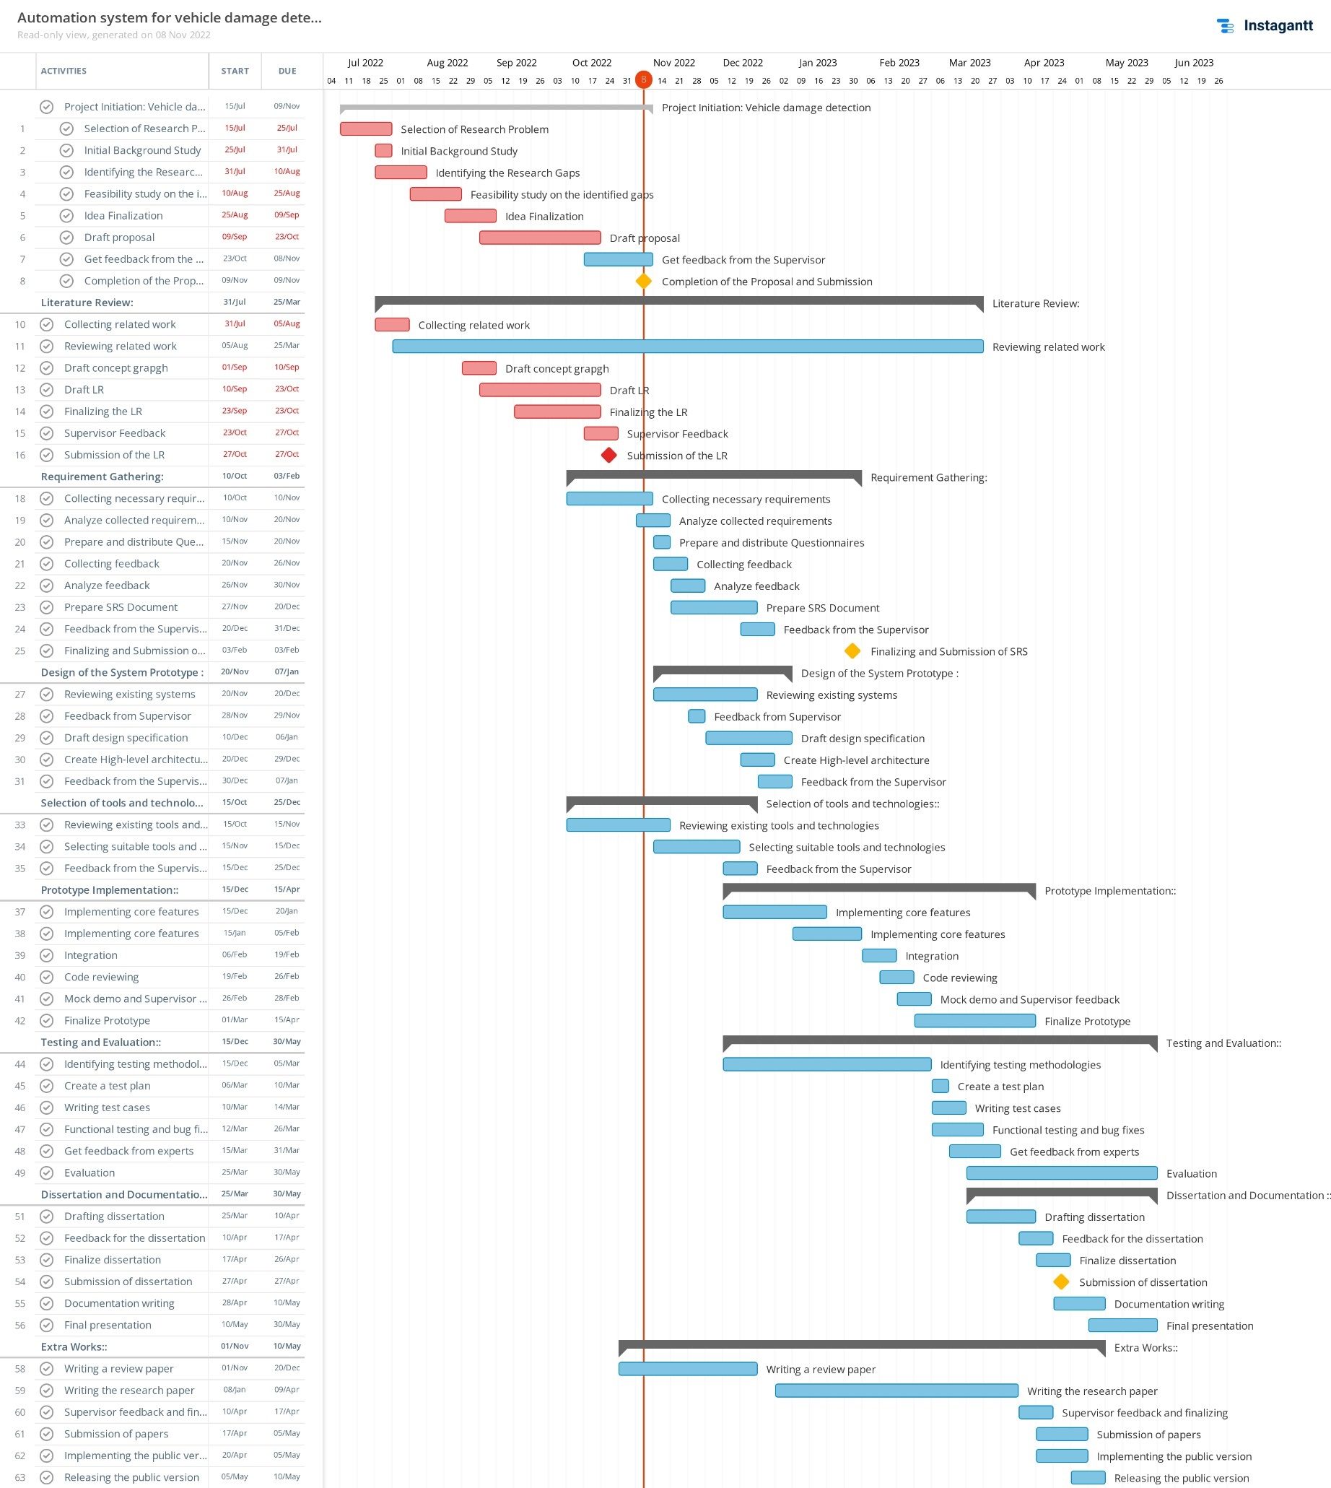

Figure 2 - Gantt chart

#### 2.6.2.2 Deliverables and dates

|  |  |
| --- | --- |
| **Project Proposal**  Submission of the initial proposal of the document | 09th November 2022 |
| **Literature Review Document**  Reviewing existing works and solutions critically | November 2022 |
| **Software Requirement Specification**  The specifies requirements to be satisfied and developed as the final prototype and data collection techniques. | 24th November 2022 |
| **Project Specifications Design and Prototype (PSPD)** | 2nd February 2023 |
| **Test and Evaluation Report**  Documentation of tests and evaluations. | 23rd March 2023 |
| **Final Project Report**  The final report the project and research process and project decisions. | 27th April 2023 |

Table 4 - Deliverables and dates

### 2.6.3 Resource requirements

#### 2.6.3.1 Software resources

|  |  |
| --- | --- |
| **Software** | **Requirement** |
| **Operating System (macOS, Ubuntu, or Windows 10 or later)** | Although macOS and Ubuntu machines can also be used for ML code execution, Windows is the most common platform. |
| **VGG image annotator and**  **‘Labellmg’** | Annotation Tools. |
| **Python** | To be used as the primary programming language for the image processing model. |
| **PyCharm / Anaconda navigator** | Use as a model development integrated development environment. |
| **Zotero** | To manage citations |
| **MS Word** | To manage all documents with references and findings, and do the formattings for documentation. |

Table 5 - Software resources

#### 2.6.3.2 Hardware resources

Development will be done on a computer with moderate performance specifications.

|  |  |
| --- | --- |
| **Hardware** | **Requirement** |
| Intel Core i7 Processor / 2.2GHz | To increase the processing power used by all applications being developed. |
| 12GB RAM | Higher RAM can execute a higher batch size and its execution time is reduced. This project requires at least 12GB of RAM space on a windows 11 PC. |
| Nvidia GTX | To gain the image processing power for model training. Having a graphics card with cores is not mandatory the same task can be done using the processor but having a graphics card will greatly reduce the time significantly. |
| 100 GB free space Hard drive | This project requires at least 80GB of hard disk space for installed Python environment with all libraries and store all image datasets. |
| A Smartphone | Requires a smartphone capable of taking pictures and capable of an installing messaging platform. |
| Router / Modem / Ethernet cables / High-speed fiber optics cable | An active internet connection is required to run the server. Since the photo files need to be shared from the front-end mobile device to the server. |

Table 6 - Hardware resources

#### 2.6.3.3 Data requirements

|  |  |
| --- | --- |
| **Dataset** | **Requirement** |
| Vehicle image dataset | To train the model for vehicle damage detection. |

Table 7 - Data requirements

#### 2.6.3.4 Skill requirements

* Conduct proper project management.
* Conducting a literature review.
* Conducting surveys.
* The process of creating a classification model
* Use Python ML tools for image processing
* Knowledge of ML methods such as Pandas, NumPy, and TensorFlow
* Use Open-CV for image feature extraction.
* Accuracy Testing Methods Using Python
* Product testing techniques
* Meetings with experts
* Documentation skills

### 2.6.4 Risk and mitigation

|  |  |  |  |
| --- | --- | --- | --- |
| Risk | Probability of Occurrence | Magnitude of the loss | Mitigation Plan |
| Not enough time to learn required know how and acquire the skills | 5 | 5 | Allocate time only for the essentials. |
| Hard Disk Failure | 3 | 3 | Keeping multiple backups |
| Getting sick | 3 | 3 | - |
|  |  |  |  |
|  |  |  |  |
|  |  |  |  |
|  |  |  |  |
|  |  |  |  |

Table 8 - Risk and mitigation

# References

Dhieb, N., Ghazzai, H., Besbes, H., Massoud, Y., 2019. A Very Deep Transfer Learning Model for Vehicle Damage Detection and Localization, in: 2019 31st International Conference on Microelectronics (ICM). Presented at the 2019 31st International Conference on Microelectronics (ICM), IEEE, Cairo, Egypt, pp. 158–161. https://doi.org/10.1109/ICM48031.2019.9021687

Harshani, W.A.R., Vidanage, K., 2017. Image processing based severity and cost prediction of damages in the vehicle body: A computational intelligence approach, in: 2017 National Information Technology Conference (NITC). Presented at the 2017 National Information Technology Conference (NITC), IEEE, Colombo, pp. 18–21. https://doi.org/10.1109/NITC.2017.8285649

Koch, M., Wang, H., Back, T., 2018. Machine Learning for Predicting the Damaged Parts of a Low Speed Vehicle Crash, in: 2018 Thirteenth International Conference on Digital Information Management (ICDIM). Presented at the 2018 Thirteenth International Conference on Digital Information Management (ICDIM), IEEE, Berlin, Germany, pp. 179–184. https://doi.org/10.1109/ICDIM.2018.8846974

Kyu, P.M., Woraratpanya, K., 2020. Car Damage Detection and Classification, in: Proceedings of the 11th International Conference on Advances in Information Technology. Presented at the IAIT2020: The 11th International Conference on Advances in Information Technology, ACM, Bangkok Thailand, pp. 1–6. https://doi.org/10.1145/3406601.3406651

Shirode, A., Rathod, T., Wanjari, P., Halbe, A., 2022. Car Damage Detection and Assessment Using CNN, in: 2022 IEEE Delhi Section Conference (DELCON). Presented at the 2022 IEEE Delhi Section Conference (DELCON), IEEE, New Delhi, India, pp. 1–5. https://doi.org/10.1109/DELCON54057.2022.9752971

van Ruitenbeek, R.E., Bhulai, S., 2022. Convolutional Neural Networks for vehicle damage detection. Mach. Learn. Appl. 9, 100332. https://doi.org/10.1016/j.mlwa.2022.100332

Waqas, U., Akram, N., Kim, S., Lee, D., Jeon, J., 2020. Vehicle Damage Classification and Fraudulent Image Detection Including Moiré Effect Using Deep Learning, in: 2020 IEEE Canadian Conference on Electrical and Computer Engineering (CCECE). Presented at the 2020 IEEE Canadian Conference on Electrical and Computer Engineering (CCECE), IEEE, London, ON, Canada, pp. 1–5. https://doi.org/10.1109/CCECE47787.2020.9255806

Zhang, Q., Chang, X., Bian, S.B., 2020. Vehicle-Damage-Detection Segmentation Algorithm Based on Improved Mask RCNN. IEEE Access 8, 6997–7004. https://doi.org/10.1109/ACCESS.2020.2964055